EXP NO 2: CREATE A SIMPLE CLOUD SOFTWARE APPLICATION FOR FLIGHT RESERVATION SYSTEM USING ANY CLOUD SERVICE PROVIDER TO DEMONSTRATE SAAS.

AIM: To create a simple cloud software application for flight reservation system using any cloud service provider to demonstrate Saas.

PROCEDURE:
Step1: Go To Zoho.Com.
Step 2: Log Into The Zoho.Com.
Step 3: Select One Application Step.
Step4: Enter Application Name As Flight Reservation System.
Step 5: Created New Application Flight Reservation System.
Step 6: Select One Form
Step 7: The Software Has Been Created.

IMPLEMENTATION:
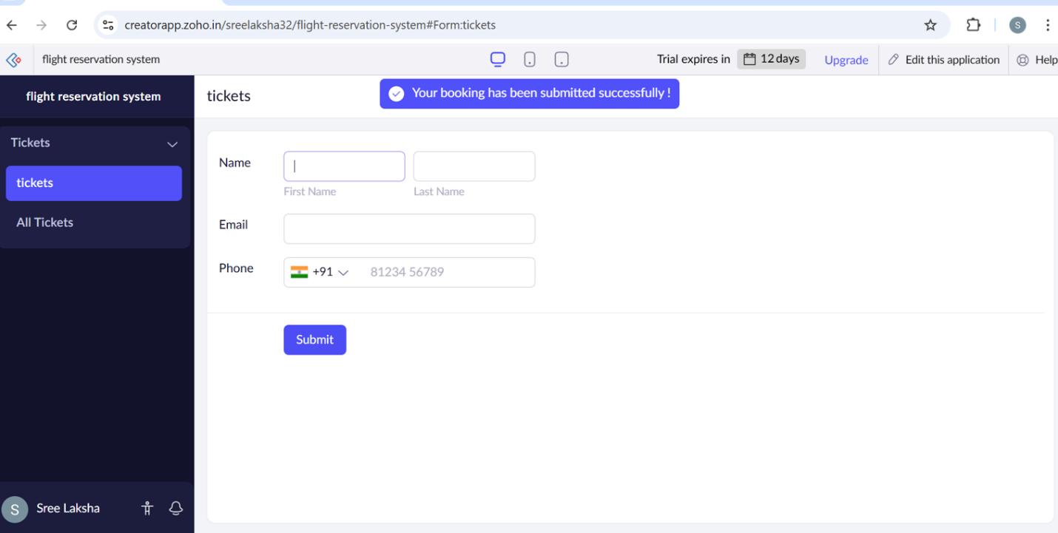

RESULT:
Thus the flight reservation system was done successfully.

